

|  |
| --- |
| FY2024 Work Program Summary |
|  |
| October 1, 2023 through September 30, 2024  Wastewater And Treatment Education Roundtable |

# Overview

|  |
| --- |
| The Wastewater And Treatment Education Roundtable (WATER) is a partnership between North Central Texas Council of Governments (NCTCOG), municipalities, and water utilities in the North Texas region that aims to educate the public about issues associated with the improper disposal of fats, oils, and grease (FOG), such as property damage, health hazards, and environmental problems. In 2015, the group decided to expand its mission to include issues related to disposables such as flushable wipes, paper towels, and pharmaceuticals. |
| *WATER’s mission is to help reduce potential damage to the region’s household plumbing systems and wastewater treatment systems as well as to decrease hazards to water quality through educational efforts related to the proper disposal of items such as wipes; paper towels; feminine hygiene and personal care products; medicines; household hazardous waste; and fats, oils, and grease (FOG).* |

In Fiscal Year 2024, WATER had twenty-one cost-sharing participants, hosted the annual Holiday Grease Roundup, hosted four roundtable meetings, and continued the Defend Your Drains North Texas (DYD) advertising and continued converting existing educational explainer videos into Spanish.

Thank you to the following entities for contributing financially to the FY2024 WATER Work Program:

* City of Arlington
* City of Cedar Hill
* City of Colleyville
* City of Denton
* City of Duncanville
* City of Farmers Branch
* City of Grand Prairie
* City of Haltom City
* City of Highland Village
* City of Irving
* City of Lewisville
* City of Mansfield
* City of McKinney
* City of North Richland Hills
* City of Plano
* City of Richardson
* City of Waxahachie
* City of Wylie
* Mustang Special Utility District
* North Texas Municipal Water District
* Trinity River Authority

### Meetings

During FY 2024, WATER held four meetings, with a topic presentation from the city of Plano.

|  |  |  |  |  |
| --- | --- | --- | --- | --- |
| Date | Oct 19, 2023 | Jan 18, 2024 | Apr 23, 2024 | Jul 18, 2024 |
| Number of Attendees | 21 | 14 | 25 | 27 |

Thank you to the City of Plano for providing a presentation on Plano’s Clean Water Initiatives and Awareness Programs which included “Keeping Our Water Clean in Plano”. Meeting summaries and presentations are available for review on the [WATER committee webpage](https://www.nctcog.org/envir/committees/wasterwater-and-treatment-education-roundtable).

### Social Media and Defend Your Drains North Texas Website Analytics

NCTCOG spent funds on Google Advertising which increased the reach of the Defend Your Drains North Texas message. This reach led to an increase in traffic to the [Defend Your Drains North Texas website](http://defendyourdrainsnorthtexas.com/).

While engagements on social media posts on the Defend Your Drains North Texas Facebook, Instagram and Twitter accounts decreased significantly due to the lack of sponsored or boosted posts on those platforms, overall Facebook showed a 3% follower increase, Instagram had a 13% increase and Twitter showed an 8% increase from the previous fiscal year.

In addition to tracking Facebook and Twitter analytics, in FY2022, NCTCOG also began tracking analytics associated with the Defend Your Drains North Texas Instagram account. As of September 30, 2023, the Defend Your Drains North Texas Instagram account had 172 followers and made 132 posts.

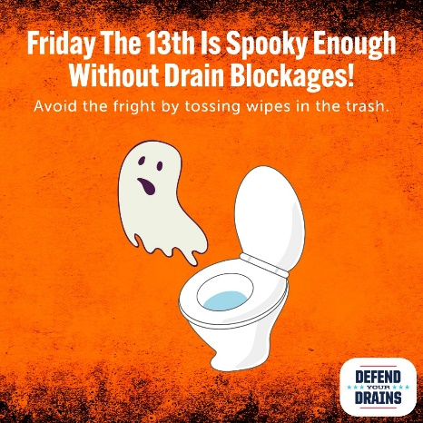

|  |  |
| --- | --- |
| Defend Your Drains North Texas – Social Media Analytics | |
| Facebook | |
| October 1, 2023 – September 30, 2024 | |
| Followers | 462 |
| Number of engagements | 281 |
| Number of impressions | 9,824 |
| October 1, 2017 – September 30, 2023 | |
| Followers | 462 |
| Number of engagements | 20,263 |
| Number of impressions | 1,279,239 |

|  |  |
| --- | --- |
| Defend Your Drains North Texas – Social Media Analytics | |
| Twitter | |
| October 1, 2023 – September 30, 2024 | |
| Followers | 170 |
| Number of engagements | 220 |
| Number of impressions | 6,251 |
| October 1, 2017 – September 30, 2023 | |
| Followers | 170 |
| Number of engagements | 2,810 |
| Number of impressions | 223,235 |

|  |  |
| --- | --- |
| Defend Your Drains North Texas – Social Media Analytics | |
| Instagram | |
| October 1, 2023 – September 30, 2024 | |
| Followers | 182 |
| Number of engagements | 426 |
| Number of impressions | 1,826 |
| October 1, 2017 – September 30, 2023 | |
| Followers | 182 |
| Number of engagements | 926 |
| Number of impressions | 6,526 |

*Social Media Analytics Definitions:*

* Number of engagements: number of times a user interacts with the content (liking, sharing, commenting, etc.).
* Number of impressions: number of times users see the content.

The most popular post on the Defend Your Drains North Texas Facebook in FY2024 was originally posted on September 18, 2023. This post had five reactions. The most popular post on the Defend Your Drains North Texas Twitter in FY2024 had three likes, 150 impressions, and two retweets. The most popular post on the Defend Your Drains North Texas Instagram in FY2024 had eight likes, and twenty-two impressions.

The Defend Your Drains North Texas website continued to experience a prominent level of success in the number of users and sessions, both significantly higher than in previous years. The bounce rate, or percentage of users that only view one page before exiting the website, also decreased by approximately 10%. However, due to changes within Google Analytics in July 2023, some of the previous analytics, including page views, pages per session, and bounce rate are no longer easily accessible in the analytics viewer. These analytics below represent only October 1, 2023, through September 30, 2024. NCTCOG is continuing to evaluate the best metrics to track for the Defend Your Drains North Texas website.

|  |  |
| --- | --- |
| Defend Your Drains North Texas - Website Analytics | |
| October 1, 2023 – September 30, 2023 | |
| Sessions | 14,476 |
| Users | 12,205 |
| Page Views* | 21,376 |
| Pages/Session* | 1.5 |
| Average Session Duration | 01.38.00 |
| Bounce Rate* | 55.29% |
| Engaged Sessions | 6,398 |
| % New Sessions | 93% |
| October 1, 2017 – September 30, 2023 | |
| Sessions | 76,447 |
| Users | 66,856 |
| Page Views | 113,566 |
| Pages/Session | 1.49 |
| Average Session Duration | 01.14.30 |
| Bounce Rate | 66.67% |
| Engaged Sessions | 6,398 |
| % New Sessions | 93% |

*Website Analytics Definitions:*

* Sessions: number of times a single user visits the website.
* Users: number of unique visitors.
* Page views: number of views each individual page received.
* Pages/Session: number of pages viewed by a single user.
* Average Session Duration: average amount of time spent on the website by a single user.
* Bounce rate: percentage of visitors that leave the website after only viewing one page.
* Engaged Sessions: a session that lasts longer than 10 seconds, has key events, or has at least 2 page views or screen views.
* % New sessions: percentage of new users visiting the website.

### Education and Outreach

In FY2024, videos for the FOGs, Wipes, Household Hazardous Waste, and Medication combined surpassed 25,000 views, with the most popular video being Proper Disposal of Household Hazardous Waste and Fats, Oils, and Grease. These videos are available on the [NCTCOG E&D YouTube page](https://www.youtube.com/user/NCTCOGED).

|  |  |
| --- | --- |
| Video Name | Number of Views |
| Wipes Clog Pipes | 3,637 |
| Fats, Oils, and Grease | 4,858 |
| Drug Take Back | 355 |
| Proper Disposal of Household Hazardous Waste | 13,796 |
| The Simple Life Cycle of Drinking Water | 486 |
| Why Your Sink Disposal Isn’t a Garbage Can | 899 |
| Always Trash Your Personal Care Items | 113 |
| Only the 3 P’s | 57 |
| Annual Holiday Grease Roundup | 523 |
| Disposal of Home Cleaning Products | 805 |
| FOGS: Los Aceites y Las Grasas | 59 |
| Las Toallitas Lo Obstruyen Todo | 20 |
| Los Residuos Peligrosos del Hogar | 60 |
| La Eliminacion Correcta de Medicamentos | 31 |
| **Total Views:** | 25,699 |

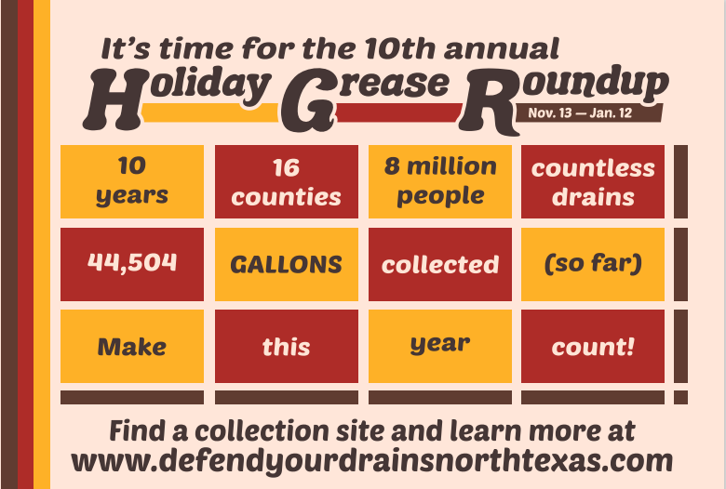

### 10th Annual Holiday Grease Roundup

During the 10th Annual Holiday Grease Roundup, thirty-six entities participated and collected 5,857 gallons of grease! Since the inception of the Holiday Grease Roundup, participants have collected over 50,361 gallons of grease. Results from the 10th Holiday Grease Roundup and past years are shown in the table below.

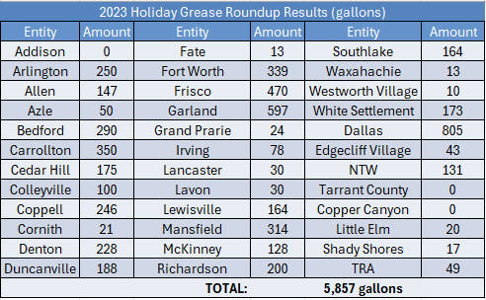

*.*

|  |  |
| --- | --- |
| Holiday Grease Roundup – Historic Data | |
| **Year** | Amount Collected (Gallons) |
| 2014 | 984 |
| 2015 | 2,773 |
| 2016 | 5,034 |
| 2017 | 4,000 |
| 2018 | 3,581 |
| 2019 | 3,502 |
| 2020 | 6,693 |
| 2021 | 8,445 |
| 2022 | 9,492 |
| 2023 | 5,857 |
| **Total:** | 40,869 |

### Looking Forward to FY2025

In FY2025, NCTCOG will continue to facilitate meetings, utilize Google analytics, and manage the 11th Annual Holiday Grease Roundup. NCTCOG will also continue developing Spanish translated explainer videos and more as directed by cost-sharing members.

More information on the FY2025 Work Program can be found [online](https://www.nctcog.org/getmedia/ae9a5e5a-fcc2-4eed-b571-258a5d2a5b57/FY2023_WATER_Work-Program-Final.pdf). If you are interested in participating, please email Hannah Ordonez at [hordonez@nctcog.org](mailto:hordonez@nctcog.org).

Thanks again for a momentous year! The work we do is not possible without your support. If you have any questions, comments, or concerns, please contact Hannah Ordonez, Senior Environment and Development Planner, at [hordonez@nctcog.org](mailto:hordonez@nctcog.org) or (817) 695-9215.