FY2024-2025 NCTCOG Solid Waste Grant Application – Standard Grant Application for Illegal Dumping Cameras
Please complete this document in its entirety to be considered for solid waste grant funding from the North Central Texas Council of Governments. Do not remove any section titles or existing text. Applications are due through the online portal at https://solidwastegrants.nctcog.org/ by 5:00 PM (CST) on May 31, 2023. Additional details on how to complete the application, the grant requirements, and other information are available in the Grant Application Guidelines.
Submitting Entity Name:
Department/Division:
Current Solid Waste Provider:
Current Recycling Service Provider:
Project Contact Name:
Project Contact Title:
Project Contact’s Direct Telephone/Fax:
Email Address:
Street Address (No PO Boxes):
Secondary Project Contact Name:
Secondary Project Contact Title:
Secondary Project Contact’s Direct Telephone/Fax:
Email Address:
Street Address (No PO Boxes):
Primary Financial Contact – Authorized Representative:
Financial Contact Title:
Financial Contact’s Direct Telephone/Fax:
Email Address:
Street Address (No PO Boxes):
Type of Eligible Entity: (check one)
☐ City
☐ County
☐ Public school or school district (excluding universities and other post-secondary institutions)
☐ General and special law districts in accordance with state law with the authority and responsibility for water quality protection or municipal solid waste management to include river authorities

Grant Project Information:
Project Title:
Project Abstract: Provide a short description (3 to 4 sentences maximum) of the proposed project here.
Which TCEQ funding category does this program fall under? A detailed description of each funding category is available for review in the Grant Application Guidelines. (check one)

☒ Local Enforcement

Which goal area from Planning for Sustainable Materials Management in North Central Texas does this program fall under? A detailed list of regional plan goals and objectives is available for review in the Grant Application Guidelines. (check one)

☒ Promote Creation and Expansion of Waste Management Programs

Grant Narrative:
Please respond to each of the below questions. Please reference the scoring sheet located in the Grant Application Guidelines for additional information on how this section will be scored. (500 words maximum).
Questions to Answer for Standard Grant Application – Illegal Dumping Cameras:
- Please provide a general overview of your entity (population, department/number of staff in charge of illegal dumping enforcement and/or site cleanup, any related solid waste/recycling activities, etc.).
- How many illegal dump sites does your entity actively monitor?
- Where are the illegal dump sites located and how frequently are they monitored?
- Quantify the costs of the illegal dump site cleanup and monitoring, if able.
- How does illegal dumping enforcement at your entity currently operate?
- How do you intend to utilize the equipment, if funded?
- How will this project benefit your illegal dumping enforcement practices and clean up activities?
- How do you intend to clean up existing illegal dumping sites? Future illegal dumping sites?

Budget:
For the Standard Grant Application – Illegal Dumping Cameras, please pick ONE budget option of the two listed below (delete the option not selected). Items included in the below budgets have been vetted by NCTCOG. You may scale up the quantity requested but do not reduce the quantity or remove items as the budget meets the minimum funding request of $15,000. NCTCOG has provided the estimated cost of each item in the budget and will provide the required proof of cost to the Grant Selection Subcommittee. You may include additional items in the budget that further support the application, but quotes or other proof of costs of those items must be included by the applicant and each line item must equal or exceed $500.00 to be an eligible expense. If you require assistance on this section, please contact Hannah Allen with NCTCOG at hallen@nctcog.org.
Option 1: Game Cameras with Night Vision Goggles, DSLR Camera Kit, and accessories
Budget Categories | Total Funding Request Per Category
1. Equipment (unit cost of $5,000 or more) | $8,500.00
2. Construction | $
3. Contractual (other than for Construction) | $
4. Other Expenses | $6,600.00
TOTAL GRANT FUNDS REQUESTED | $15,100.00

1. Equipment (Unit Price of $5,000 or more)
Item/Description | Purpose | Quantity | Unit Cost | Total Amount Requested
Night Vision Goggles | Illegal dump site investigation for prosecution | 1 | $8,500.00 | $8,500.00
 |  |  | $ | $
Total Equipment Budget |  |  |  | $8,500.00

2. Construction
Description | Purpose | Quantity | Unit Cost | Total Amount Requested
 |  |  | $ | $
 |  |  | $ | $
Total Construction Budget |  |  |  | $

3. Contractual (other than for construction)
Description | Purpose | Quantity | Unit Cost | Total Amount Requested
 |  |  | $ | $
 |  |  | $ | $
Total Contractual Budget |  |  |  | $

4. Other Expenses
Description | Purpose | Quantity | Unit Cost | Total Amount Requested
Browning Recon Force Patriot Trail Camera | Capture illegal dump site activity | 13 | $200.00 | $2,600.00
DSLR Camera and Accessories (camera body, carrying case, memory card, flash kit, lens kit) | Capture illegal dump site activity for prosecution | 1 | $4,000.00 | $4,000.00
Total “Other” Budget |  |  |  | $6,600.00

Option 2: Cellular Security Cameras with DSLR Camera Kit and accessories
Budget Categories | Total Funding Request Per Category
1. Equipment (unit cost of $5,000 or more) | $
2. Construction | $
3. Contractual (other than for Construction) | $
4. Other Expenses | $15,250.00
TOTAL GRANT FUNDS REQUESTED | $15,250.00

1. Equipment (Unit Price of $5,000 or more)
Item/Description | Purpose | Quantity | Unit Cost | Total Amount Requested
 |  |  | $ | $
 |  |  | $ | $
Total Equipment Budget |  |  |  | $

2. Construction
Description | Purpose | Quantity | Unit Cost | Total Amount Requested
 |  |  | $ | $
 |  |  | $ | $
Total Construction Budget |  |  |  | $

3. Contractual (other than for construction)
Description | Purpose | Quantity | Unit Cost | Total Amount Requested
 |  |  | $ | $
 |  |  | $ | $
Total Contractual Budget |  |  |  | $

4. Other Expenses
Description | Purpose | Quantity | Unit Cost | Total Amount Requested
Reconyx Hyperfire Cellular Security Cameras | Capture illegal dump site activity | 18 | $625.00 | $11,250.00
DSLR Camera and Accessories (camera body, carrying case, memory card, flash kit, lens kit) | Capture illegal dump site activity for prosecution | 1 | $4,000.00 | $4,000.00
Total “Other” Budget |  |  |  | $15,250.00

Applicant’s Match
Amount: $
Narrative: Please provide a description and breakdown of the anticipated matching funds that will be provided as a part of the proposed project. Note: matching funds are not required for these grants.
If more money becomes available, could the proposed project be expanded? ☐ Yes ☐ No
If the proposed project is unable to be fully funded, would you be able to accept partial funding? ☐ Yes ☐ No
Please briefly describe the top funding priorities if you can accept partial funding.

Do you have a preference on which fiscal year you receive the funding?
☐ First FY ☐ Second FY ☐ No preference

Timeline:
In this section, provide a detailed description of the proposed project’s timeline, including specific activities and the responsible party for each. Please reference the grant application portal for an example project timeline. For information on how this section will be scored please review the Grant Application Guidelines. Additional rows can be added as necessary.
Activity | Responsible Party | Estimated Start Date | Estimated Completion Date | Additional Information
EX: Execution of Interlocal Agreement | Applicant/NCTCOG | September 2023 | October 2023
EX: Procurement of grant items | Applicant Purchasing Department | November 2023 | January 2023 | Applicant to provide procurement documentation to NCTCOG for review prior to purchase
EX: Receipt and payment of grant items | Applicant | February 2023 | February 2023
EX: Installation of cameras | Applicant | April 2023 | June 2023 | Applicant to coordinate with code enforcement officers on locations for installation
EX: Track progress and reporting | Applicant | June 2023 | August 2024 | Applicant to coordinate with NCTCOG on camera usage, providing completed reports as necessary, etc.

Grant Application Checklist:
☐ Completed Grant Narrative
☐ Completed Budget section
☐ Provided supplemental documentation for the budget and proposed project
☐ Completed Timeline Section
☐ Attached Resolution/Court Order

Appendix 1: Example Photos of Budgeted Items
Option 1: Game Cameras with Night Vision Goggles, DSLR Camera Kit, and accessories

DSLR Camera with accessories:
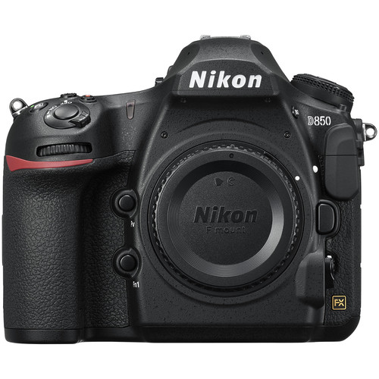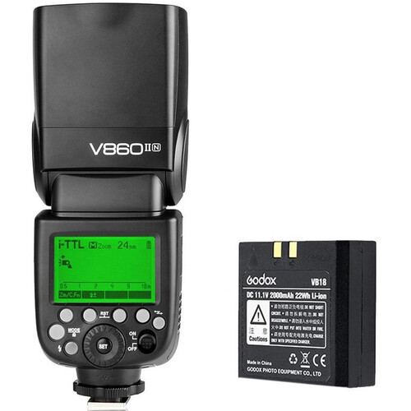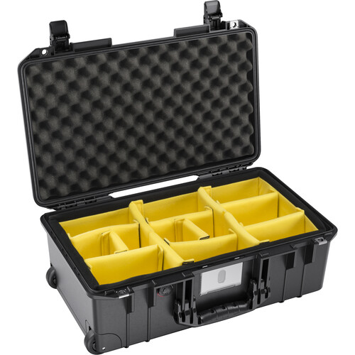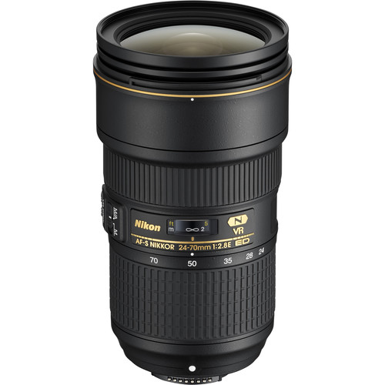

Night Vision Goggles: Game Cameras:
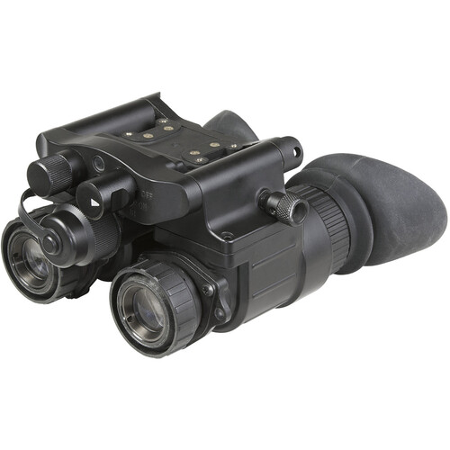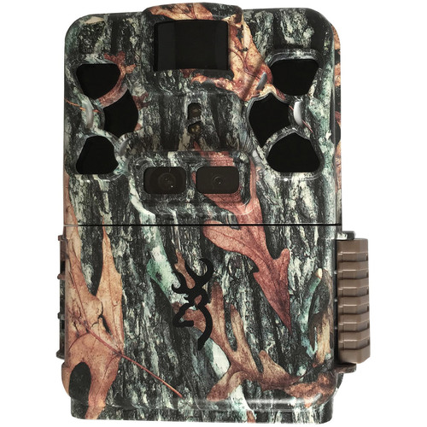

Option 2: Cellular Security Cameras with DSLR Camera Kit and accessories
Cellular Security Cameras:
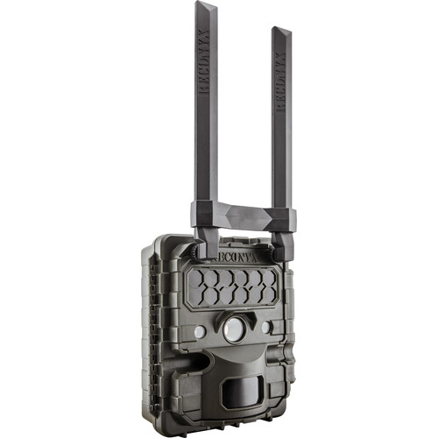
DSLR Camera with accessories:

