**Texas Stream Team Workshop**

The workshop will address the barriers faced by prospective partners, offer guidance to partners seeking to re-establish their Citizen Scientist program, and gather feedback from active partners. The workshop will provide a platform for new and current partners to collaborate, as well as improve and expand Texas Stream Team efforts in the North Central Texas Region.

**Texas Stream Team Workshop**

The workshop will address the barriers faced by prospective partners, offer guidance to partners seeking to re-establish their Citizen Scientist program, and gather feedback from active partners. The workshop will provide a platform for new and current partners to collaborate, as well as improve and expand Texas Stream Team efforts in the North Central Texas Region.

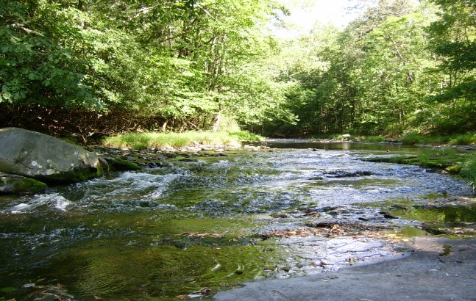

**Workshop Details**

**Date and Time**:Tuesday,March 6, 2018, 9AM

**Location**:William J. Pitstick Executive Board Room,NCTCOG, 616 Six Flags Dr., CPII, Arlington, TX 76011

**Workshop Details**

**Date and Time**:Tuesday,March 6, 2018, 9AM

**Location**:William J. Pitstick Executive Board Room,NCTCOG, 616 Six Flags Dr., CPII, Arlington, TX 76011

To RSVP, please visit the NCTCOG Environment & Development website at <http://www.nctcog.org/envir/events.asp>

To RSVP, please visit the NCTCOG Environment & Development website at <http://www.nctcog.org/envir/events.asp>

