TEXPRESS LANES SOCIAL MEDIA POSTS

TEXpress posts to be used with graphics:

- Discounts

Facebook/IG:
TollTag customers and carpoolers get the lowest rates on #TEXpress Lanes! Carpoolers can download the GoCarma app to activate HOV discounts. Visit gocarma.com/dfw for information.

(FB Graphic)

Twitter:
TollTag customers & carpoolers get the lowest rates on #TEXpress Lanes. Get the GoCarma app and save! gocarma.com/dfw

(TW Graphic)

- Benefits

Facebook/IG:
#TEXpress Lanes consist of corridors with rebuilt frontage roads, non-tolled highway lanes and tolled lanes, resulting in reliable travel times and less congestion. Register and save today! gocarma.com/dfw

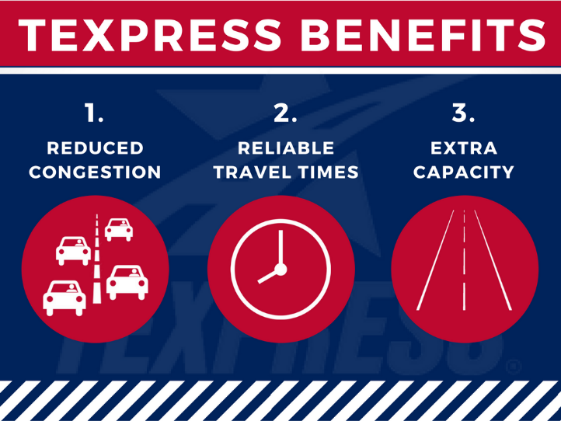

(FB Graphic)

Twitter:
#TEXpress Lanes result in reliable travel times and less congestion. gocarma.com/dfw

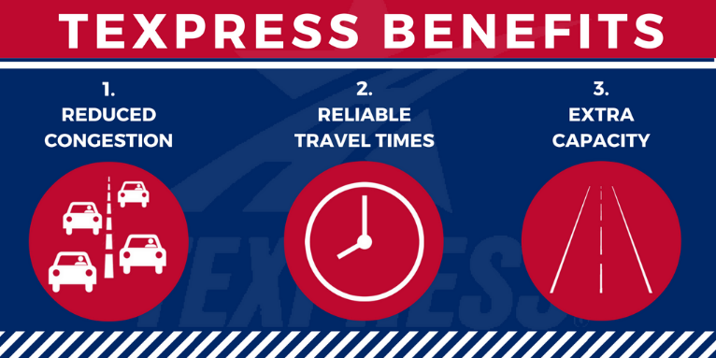

(TW Graphic)

- Easy to Use

Facebook/IG:
#TEXpress Lanes are easy to use with dedicated entrance and exit ramps, plus clearly marked prices at each entrance. Visit gocarma.com/dfw to plan learn more.

(FB Graphic)

Twitter:
#TEXpress Lanes are easy to use with dedicated entrances marked with pricing info. gocarma.com/dfw
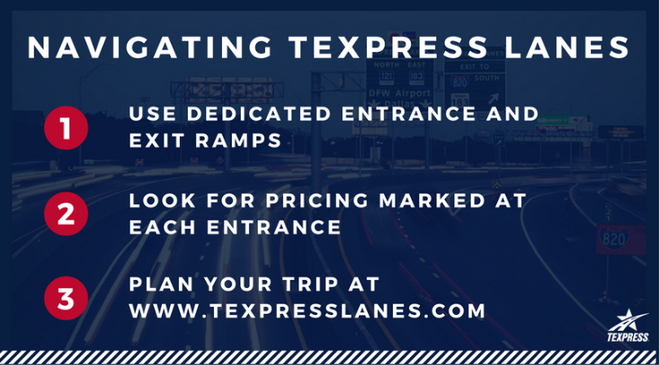

(TW Graphic)

- Your Choice

Facebook/IG:
Choose to pay for a more predictable travel experience on #TEXpress Lanes or choose to drive in the rebuilt adjacent non-tolled lanes. You decide each time you drive on a roadway with TEXpress Lanes. Visit gocarma.com/dfw.

(FB Graphic)

Twitter:
Choose a reliable commute & predictable travel times when you drive #TEXpress Lanes.
gocarma.com/dfw
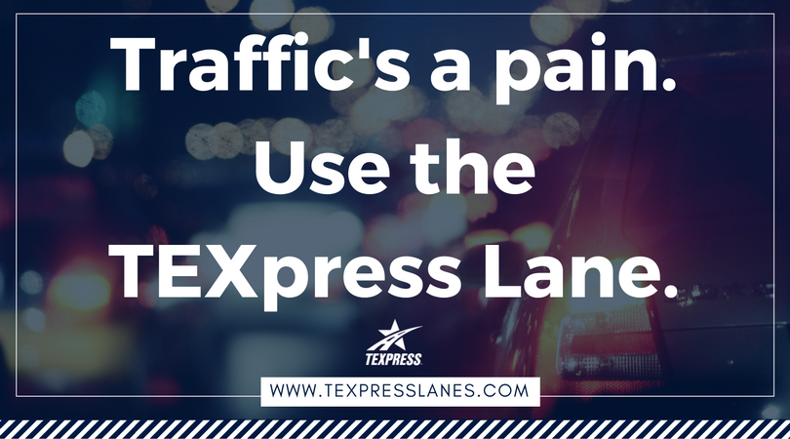

(TW Graphic)

Less Stress – Skip the Line
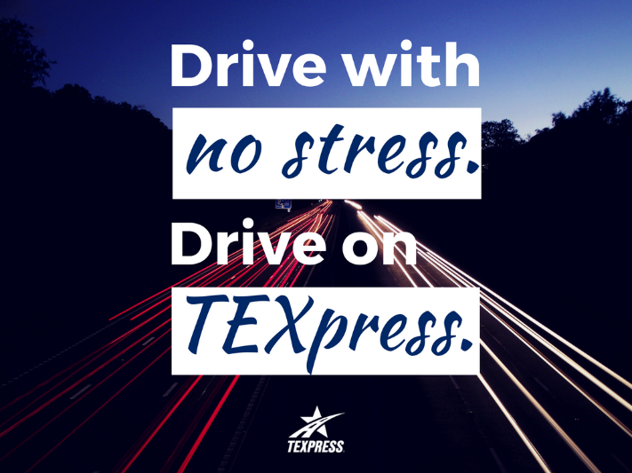

Facebook:
TEXpress Lanes lower the stress of commuting. #TEXpress Lanes are separated from the general highway lanes and have fewer entrance and exit ramps. Skip the line for a more reliable commute. gocarma.com/dfw

Twitter:
#TEXpress Lanes lower the stress of commuting. Skip the line for a more reliable commute. gocarma.com/dfw

- Ease of Payment
Facebook/IG:
Payment for driving on #TEXpress Lanes is easy! Drivers can pay electronically with TollTag, TxTAG or EZ TAG accounts or through NTTA’s ZipCash video pay-by-mail system. Get more information at gocarma.com/dfw.
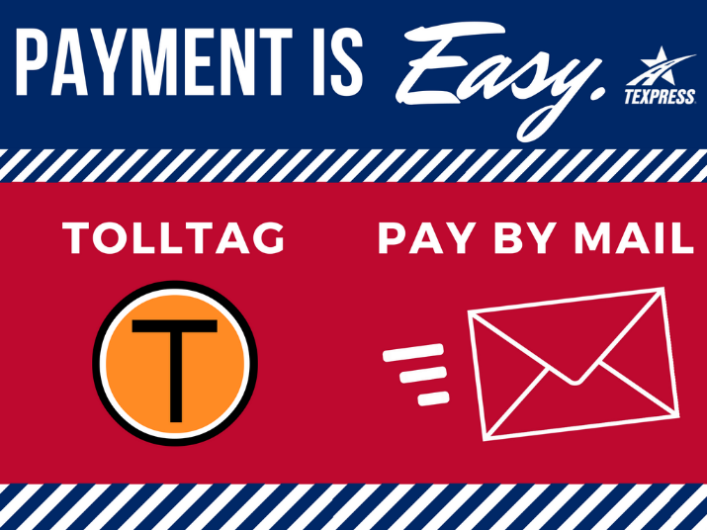

(FB Graphic)

Twitter:
Payment for driving on #TEXpress Lanes is easy! Pay electronically with a TollTag or pay-by-mail. gocarma.com/dfw

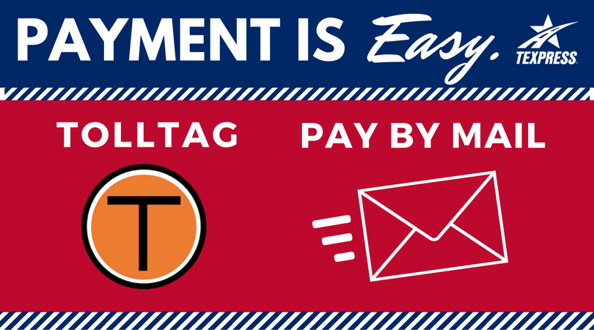

(TW Graphic)

Social Media Posts for Three Testimonial Videos:

- Stephen Apple Testimonial
Facebook:
Stephen bypasses traffic by taking the #TEXpress Lanes for a more relaxing trip to his destination.

Twitter:
Stephen gets to his destination faster and more relaxed with #TEXpress Lanes.

- Kay Byfield Testimonial
Facebook:
Kay arrives to see her grandkids feeling happy and relaxed with a stress-free drive on #TEXpress Lanes.

Twitter:
Kay takes the tension out of her travel by taking the #TEXpress Lanes to her destination.

- Shannon Brown Testimonial Video
Facebook:
Frequent travelers like Shannon can trim minutes off their travel time by taking the #TEXpress Lanes to destinations such as work or the airport.

Twitter:
Frequent travelers like Shannon can trim minutes off their travel time by taking the #TEXpress Lanes.

Social Media Posts for TEXpress educational videos

Twitter and Facebook:
- “How to Use the TEXpress Lanes” video
Want to try #TEXpress Lanes but not sure exactly how to use them? Check out this video to learn about how they work.

(with video: https://www.youtube.com/watch?v=2vzG3siyeic)

- “How to Use the TEXpress Lanes – Roadway and Pricing Signs” video
Need help understanding #TEXpress Lane signage and pricing? Check out this video to learn more about how they work.

(with video: https://www.youtube.com/watch?v=h3fiwUQQRb0)

