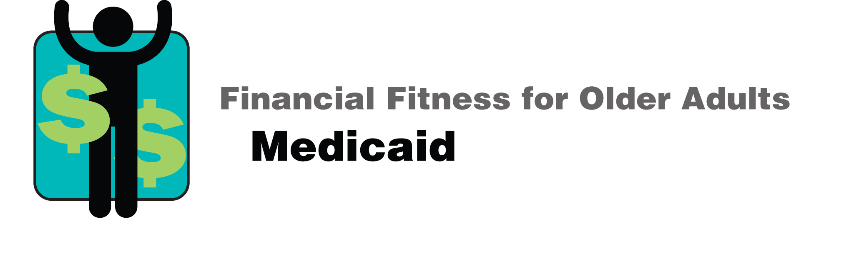

**Financial Fitness for Older Adults**

**Medicaid**

**What is the Medicaid program and who qualifies?**

The Medicaid program is for people who are over the age 65 or disabled, have very low incomes, and very limited resources. People who get Supplemental Security Income (SSI) checks automatically get Medicaid, without applying for it.

Other people need to apply for Medicaid. There are two kinds of Medicaid. Each type has its own eligibility requirements.

* Community Medicaid: In order for you to qualify in 2025, your monthly income can be no more than $967 (not counting the first $20 of income) if you’re single or $1,450 if you’re married. Your resources can be no more than $2,000 if you’re single or $3,000 if you’re married. Resources include things like cash, certificates of deposit, and property other than your homestead.
* Nursing Home Medicaid: In order for you to qualify in 2025, your monthly income can be no more than $2,901 if you’re single or $5,802 if you’re married and both of you are applying for Medicaid. Your resources can be no more than $2,000 if you’re single or $3,000 if you’re married and both of you are applying for Medicaid. Also, you have to qualify medically for nursing home care. That means the State of Texas has to certify that you need help with one or more nursing tasks.

If you’re married and your spouse isn’t applying for nursing home Medicaid, there may be higher income and resource limits for your spouse. See <https://www.nctcog.org/getmedia/c90dc5f8-d5d4-4624-a28c-621d9d6bf6fb/nursinghome.pdf.aspx> or call 1-800-252-9240 for more information.

**What does the Medicaid program pay for?**

Medicaid can pay for health care services like doctor’s visits, hospitalizations, and prescription medications. It can also pay for long-term services and supports like care in a nursing home or assisted living facility, or services in your home.

**Do I have to sell my home in order to qualify for Medicaid?**

If your home has less than $730,000 in equity, you don’t have to sell it in order to qualify for the Medicaid Program.

**Will the Medicaid program ask for money back after I die?**

The Medicaid Estate Recovery Program (MERP) is a state policy that gives Texas the right to ask for money back from your estate after you die, if you receive Medicaid benefits. The State may not ask for any money back. If it does ask for money back, it won’t ask for more than it paid for your services.

An estate includes money and other things of value that you leave to your heirs after you die. An estate usually covers property, like a house. But there is a legal way to leave your house to an heir and keep it from being affected by MERP: by having a lawyer set up a Transfer on Death Deed (TODD). Texas Legal Services Center has a program that helps some Texans with low incomes set up TODDs at no cost. Call 1-800-622-2520 for more information.

An estate does not include life insurance policies that name a person to receive payment after you die. An estate does not include bank accounts that are paid on death to another person.

**Who’s affected by the Medicaid Estate Recovery Program?**

People are affected who participate in programs that include nursing home Medicaid, Intermediate Care Facility for Individuals with an Intellectual Disability or Related Condition (ICF-IDD), Community Attendant Services through the Texas Health and Human Services Commission, STAR+PLUS Waiver services, Community Living Assistance and Support Services (CLASS), Home and Community Services (HCS), Texas Home Living (TxHmL), and Deaf-Blind with Multiple Disabilities (DBMP).

The Medicaid Estate Recovery Program also affects the cost of certain hospital and prescription drugs you get. But it does not affect Primary Home Care (PHC).

The Medicaid Estate Recovery Program does not affect people who get Medicare Savings Program benefits (like QMB, SLMB, and QI) only.

**How does the Medicaid Estate Recovery Program work?**

Once a person with certain Medicaid benefits dies, Texas sends a notice to the person in charge of the estate, asking for certain information so it can decide whether to file a claim.

Texas will not ask for money back if:

* + Your spouse who is still living.
  + You have a child under the age of 21.
  + You have a child of any age who is blind or permanently and totally disabled, according to Social Security requirements.
  + The value of your estate is less than $10,000.
  + You got less than $3,000 in Medicaid services.
  + Your unmarried child lived full time in your home for at least one year before you died.
  + The cost of selling your property is more than the property is worth.
  + MERP causes undue hardship for your heirs (the people who inherit your money and other things of value). Your heirs have to request a hardship waiver from the Texas Health and Human Services Commission. Some of the reasons it may approve hardship waivers include:
  + Your heirs would need help from the government if Texas filed a claim to get money back.
    - * + Your home’s value, according to your tax appraisal district, is less than $100,000 and your heirs have low incomes.

Attorneys with Texas Legal Services Center, available by phone at 800-622-2520**,** can provide general information about the Medicaid Estate Recovery Program. If you’d like to discuss how Medicaid Estate Recovery may affect you, you can call 800-641-9356.

**What happens if I give away my home or resources in order to qualify for Medicaid?**

Texas can “look back” for five years before you applied for Medicaid. If you gave away your property or refused to accept income, you can be denied Medicaid or assessed a penalty (e.g., have to wait several months before you start getting Medicaid).